Melissa Horan
Galls
Galls website training

Table of Contents
Logging On 2
Layout of Website 3
Placing an Order 6
Checking Order History 11
Returns 13
Who to Contact 14

Logging On

Once training is complete, you will receive an email with your username, temporary password, and a link to the new website.
Once you log in for the first time, you will be prompted to change your password. If you forget the password for future log ins, click the Forgot your password? link on the login screen.
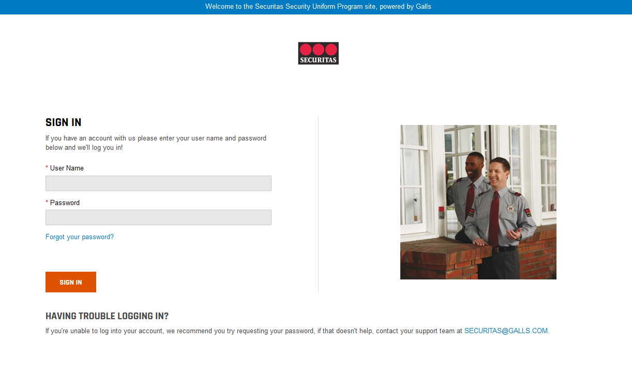

***The old web address is securitas2.galls.com, and the new web address is securitas.galls.com. Please be sure you are on the correct website.

Layout of New Website
Current Location = State(s) where you ship your orders (you may have more than one)
(
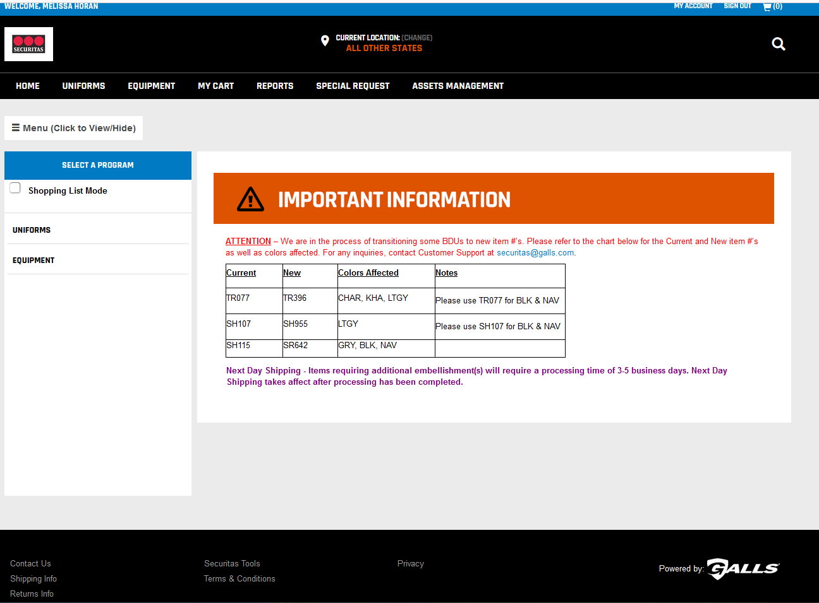
There is a tab for Uniforms and a tab for Equipment.

- States with special patching requirements are called out separately. States with standard patching are grouped together under All Other States.
- You should only be assigned to states that you are currently ordering for.
- For users with multiple state views, you can toggle back and forth by clicking the CHANGE button next to CURRENT LOCATION.

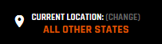

- Your location will drive the selection of items you can order, so make sure you are shopping under the correct state as you place your order.
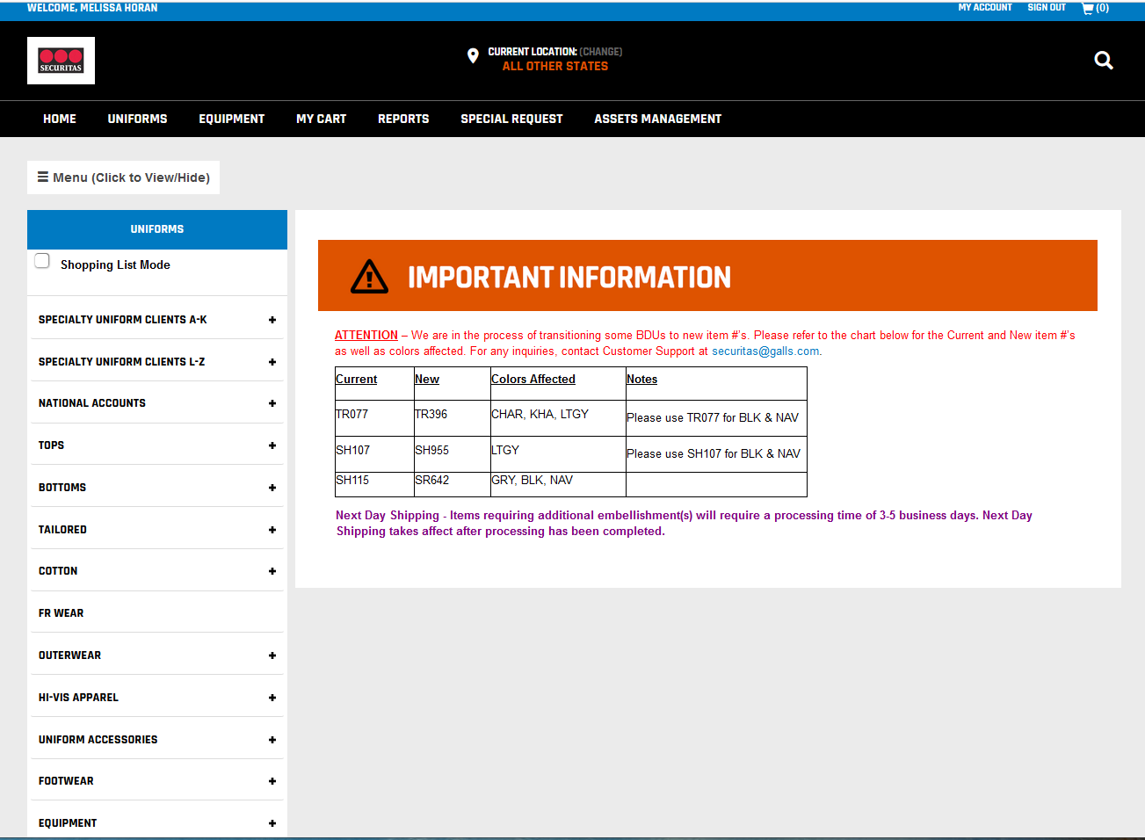
We have added separate tabs for Specialty Clients and National Accounts, listed alphabetically.
Clicking the Uniform Tab will change the left hand navigation to various categories with uniform items.

- If your client has a unique logo, you will find it under the Specialty Uniform Clients.
- Garments with standard Securitas logos are located under the corresponding garment type (Tops, Outerwear, etc).

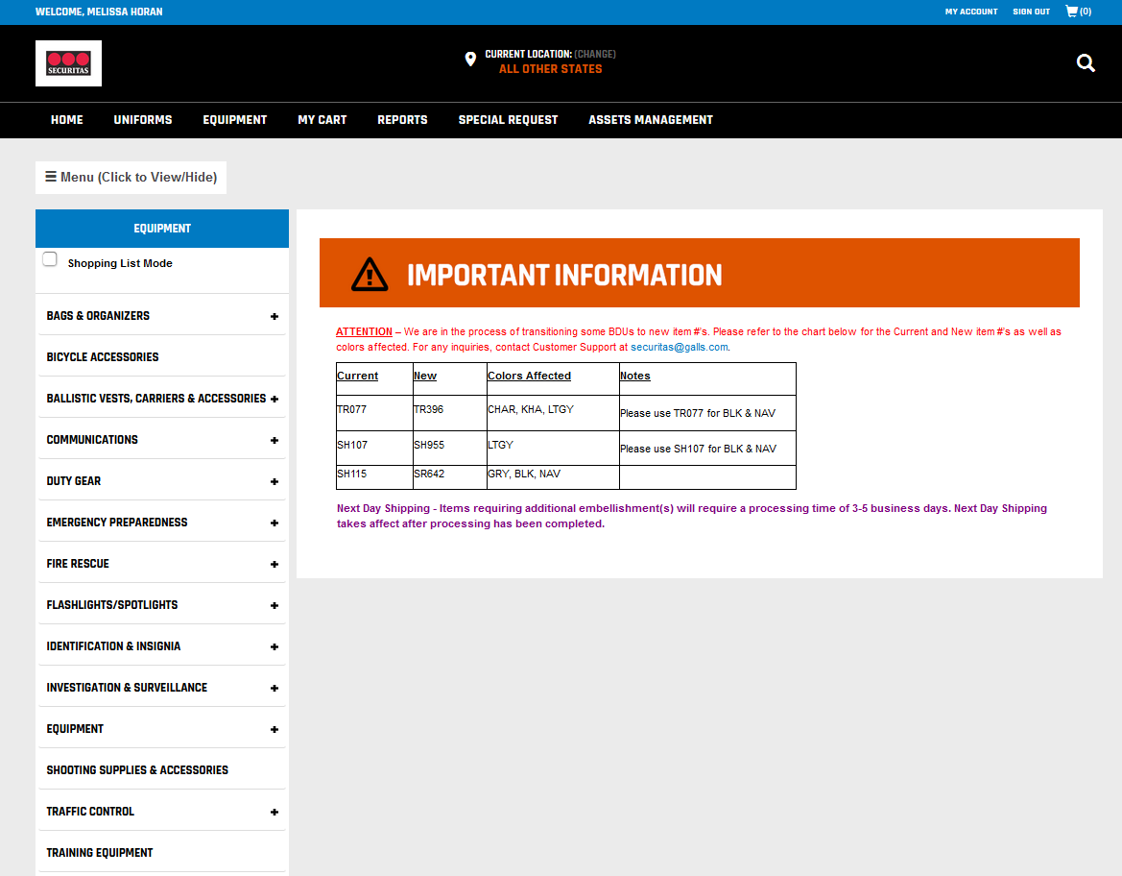
Clicking the Equipment Tab will change the left hand navigation to various categories with equipment items.

Placing an Order

NEW FEATURE – Shopping List Mode
- Shopping list mode allows you the ability to add names to items. When the items are delivered, the names will be listed on the packing slip. This will help you match items in the box with the officer.
- To use this feature, click the box next to Shopping List Mode at the top of the left-hand navigation. A text box will appear for you to type in the name of the officer. Once the name is typed in, click the Add button.

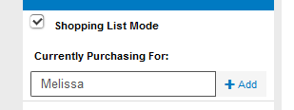

- You will be shopping for that officer until you either add a new name or release the Shopping List Mode button. The name(s) will print on the packing slip.
- Using Shopping List Mode is optional, and may not be applicable to all orders (for example – bulk orders for stock)

UPDATE TO SKUs
- The old site uses Marketing SKUs (base number + personalization). The new site will only use base numbers.
- This means the item numbers will look different than they did on the old site. Here is an example.
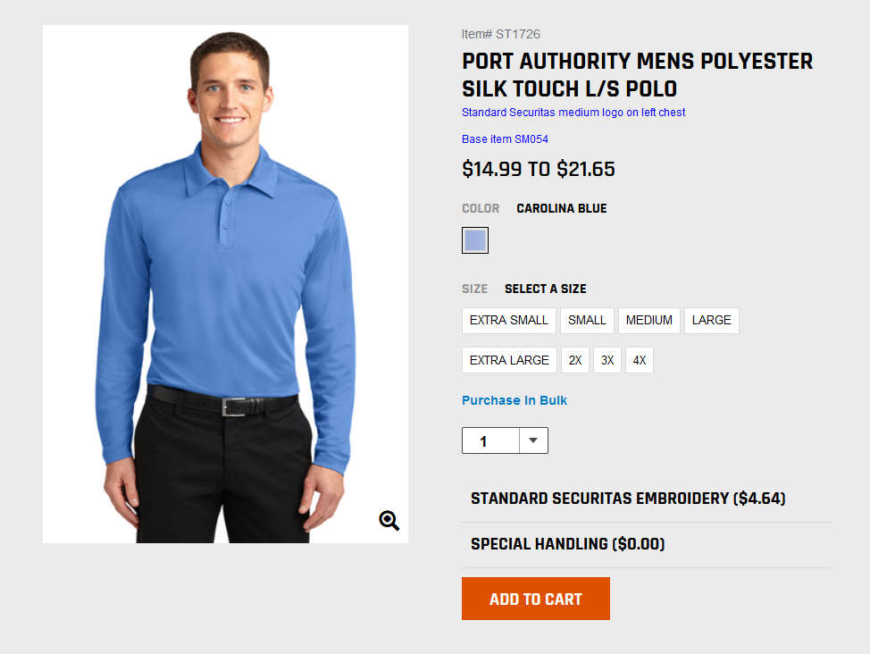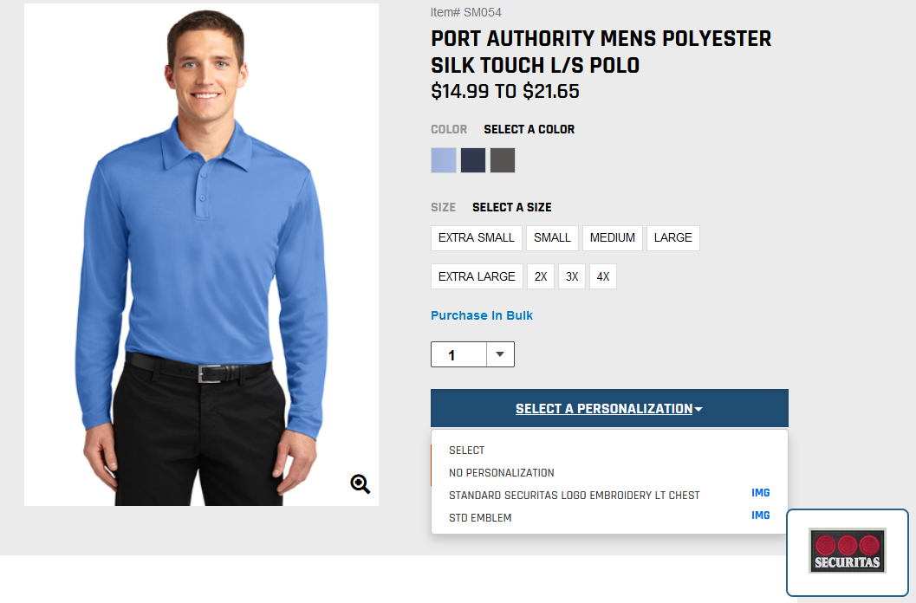
NEW SITE
This is the same polo as above, but only uses the base number (SM054).
OLD SITE
Marketing SKU – ST1726
Base number – SM054
- For now, you can use the old website to look up base numbers under the marketing SKU. You can also contact Galls for assistance with identifying the correct base number.

Placing an Order
- Find the item in the correct category on the left-hand navigation or type the base item number into the search bar.
- Make all required color and size selections on the item.
- When customization is required, click the Select a Personalization drop down menu. You can confirm that the personalization is correct by the description, as well as hovering over the IMG button to view an image.

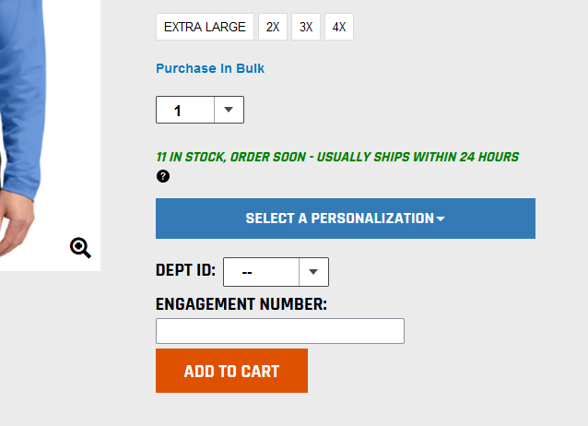

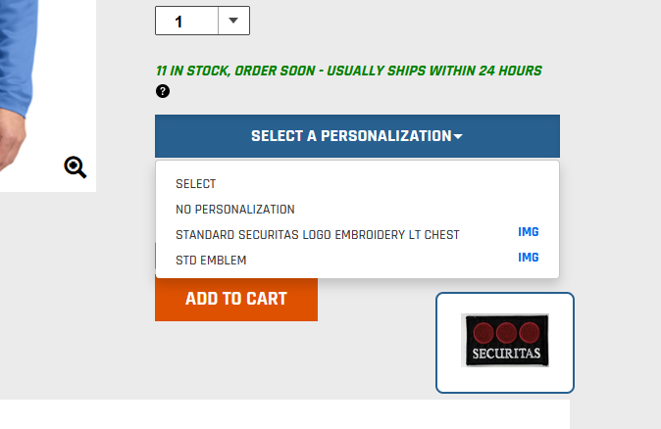

- NEW FEATURE - Select the department ID from the drop down menu. ***NOTE: This new feature allows you to combine multiple department IDs on one order. You will only see department IDs that are assigned to you in the drop down menu***
- Type in the 10-digit engagement number. Once this is complete, you can Add to Cart.

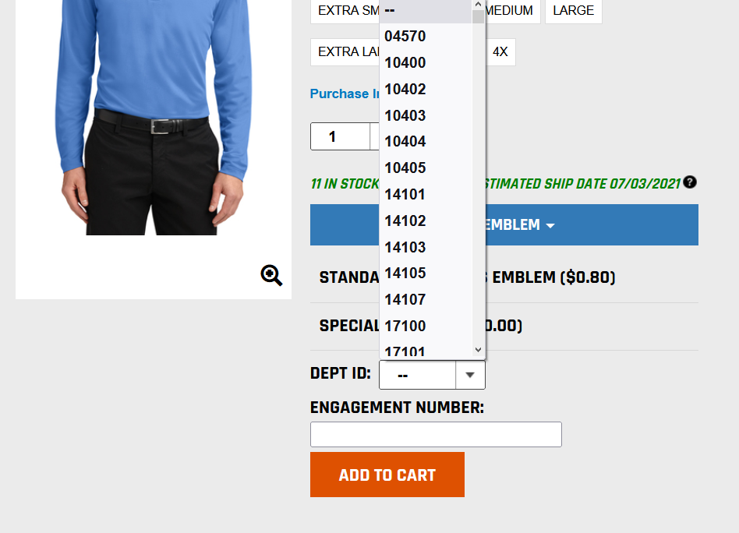

- You have the ability to check and edit the department ID(s) and engagement number(s) in your shopping cart. Confirm that all information is correct, and Proceed to Checkout.
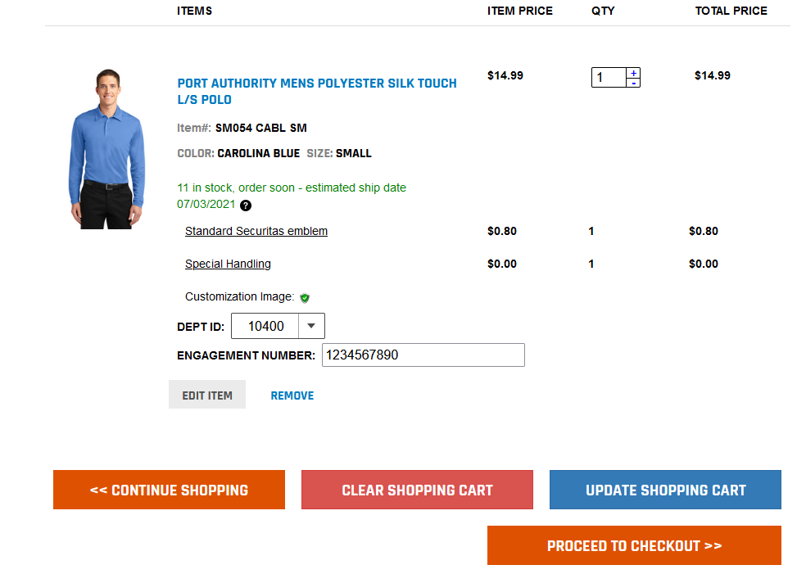
- Complete the order information.
- NEW FEATURE – You can now override the Ship to Contact if sending to a location other than your branch. To ship to yourself, click My Order. To ship to someone else, click Employee Order and override the First Name and Last Name fields to the new shipping point of contact.
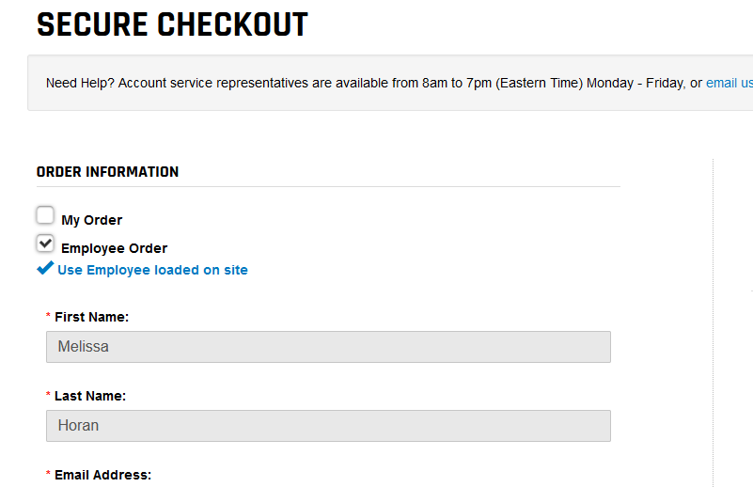
When Employee Order is selected, you can override the First Name and Last Name fields.

- If you do not see the shipping address listed, select Add New Shipping Address. Complete the shipping address form. ***NOTE: Be sure to select Personal/Shipping for the shipping type, even if it is a business address.
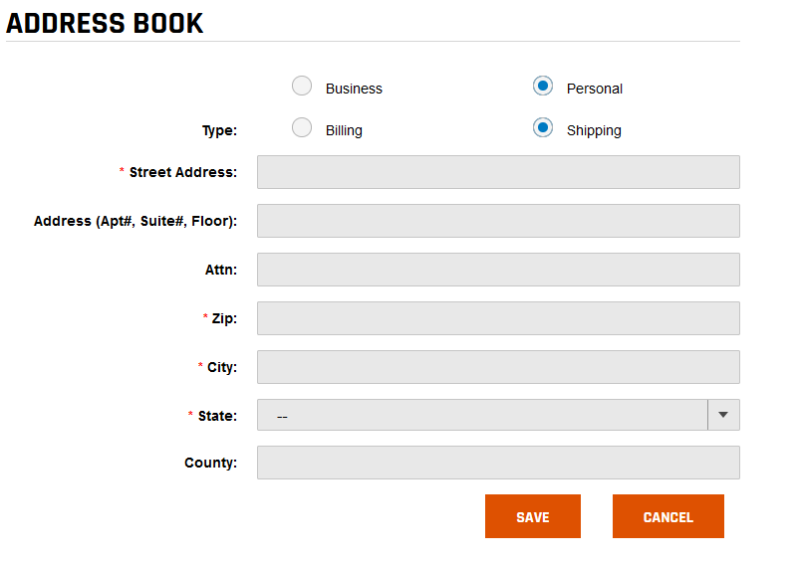

- Complete the remainder of the required Secure Checkout fields and click Continue. ***NOTE: The DIRECT BILL Y or N field will apply to the entire order. If you have orders with different Direct Billing, they will need to be placed separately.
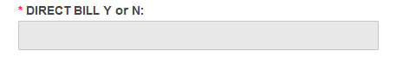
- Confirm that order details are correct and click Confirm & Submit order. An order confirmation will be emailed to you.

Order Approval
- Orders that are over $5,000 and/or use Overnight Shipping will require approval from your AVP. You will be prompted with an alert if your order qualifies for approval. You must acknowledge the alert before you can continue.
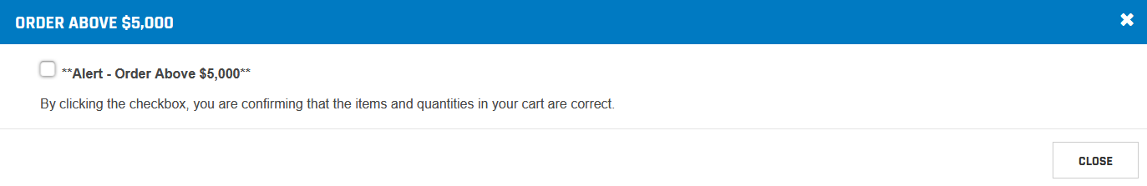
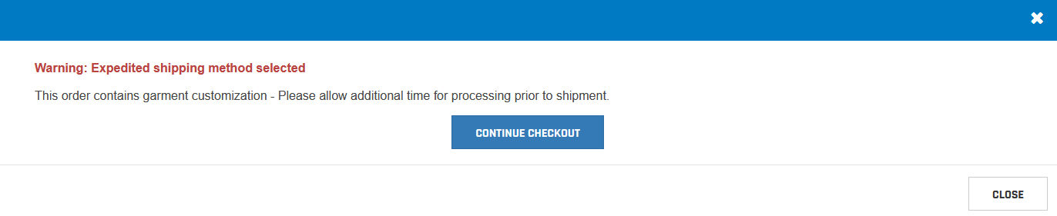

Checking Order History
- ***NOTE: You must check order history on the site where the order was placed. This means any old orders must be checked on the old Galls ordering site. We will keep the old site active for 60 days for the purpose of checking orders. You will not be permitted to place orders on the old website.
- Click My Account in the top right-hand corner, followed by Order History on the left-hand navigation.

- The most recent 5 orders are shown by default. You can enter a date range to see older orders.
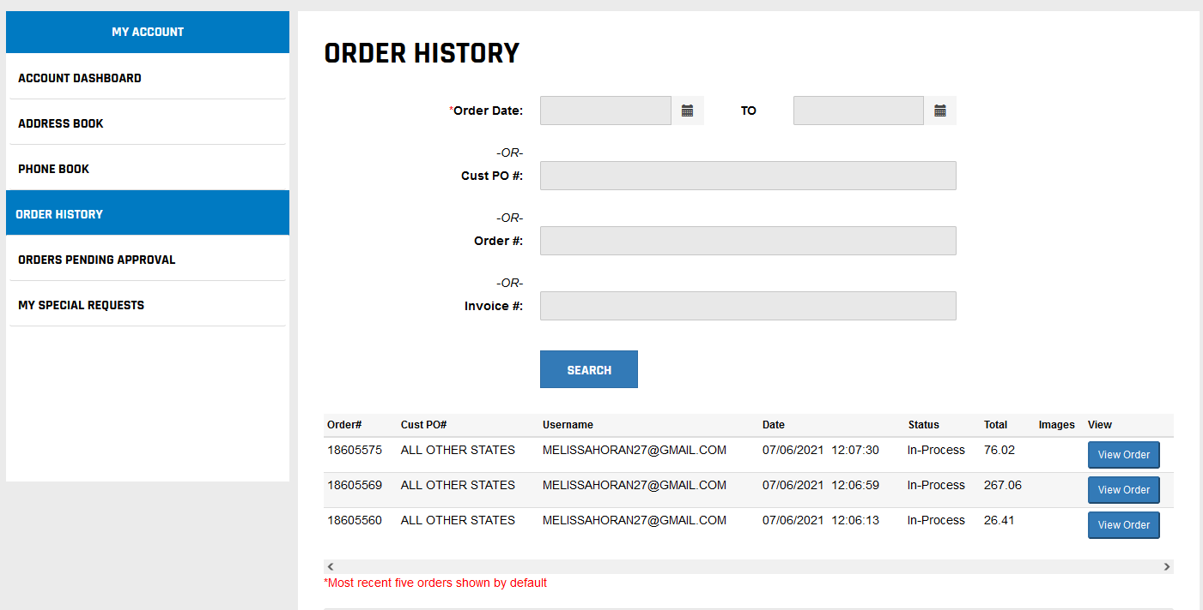
- Click the View Order button for more detail. You can expand the Product Detail Custom Invoice Detail tab to view the department ID and engagement number information.
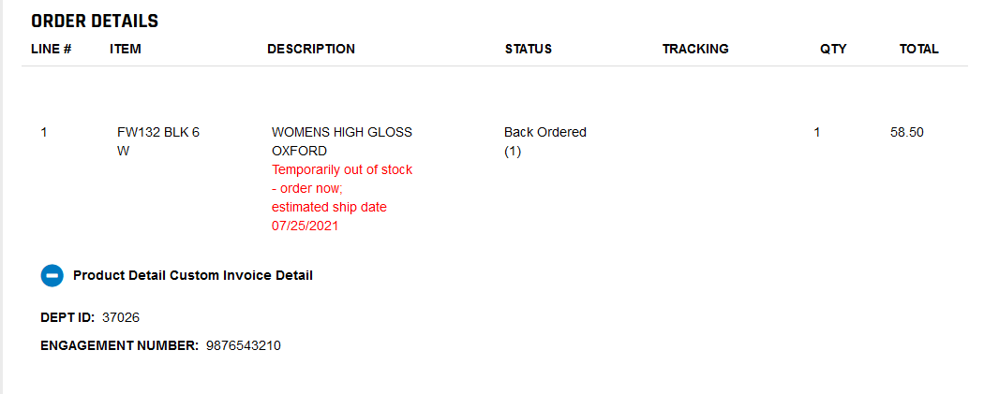

Returns
- Our Returns Policy is listed towards the bottom of the home page under Returns Info.
- ***NOTE – You MUST include the line number from the order for all returns. This is to ensure any credits/replacement are billed to the correct department ID and engagement number. The line number can be found in the Order Details under Order History.
- Using the returns form on the back of the original packing slip, you can include the line number in the Item Number column.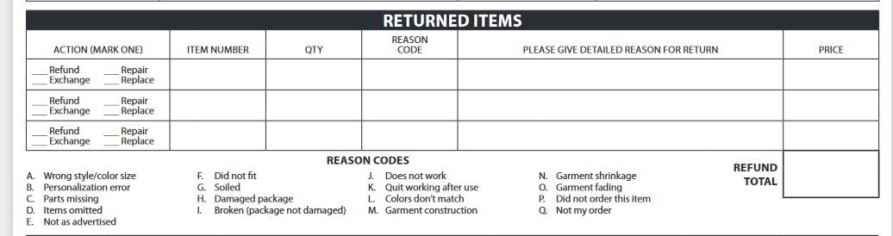

***If you do not provide the line number of the returns form, someone from Galls will reach out to you for this information. This could delay the return/exchange.

Who to Contact

- Melissa Horan
  - 859-787-0432
  - Horan-melissa@galls.com
  - When to contact
    - Website assistance (navigation, how to find items, tutorials, etc)
    - Product information (preapproved alternates)
    - Special requests
- Securitas Customer Service
  - securitas@galls.com
  - When to contact
    - Order status / tracking
    - Tracking
    - Return requests/info
    - Website login/password reset
- Securitas Uniform Administration
  - Uniform.administration@securitasinc.com
  - When to contact
    - Job start ups / large conversions
    - National Accounts
    - Billing questions
    - Sourcing product
    - Change requests

